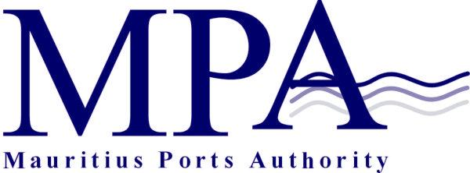
ADDENDUM TO PROCUREMENT NOTICE

INVITATION FOR EXPRESSION OF INTEREST
FOR THE ENLISTMENT OF RECOGNISED SECURITY ORGANISATIONS FOR PORT LOUIS HARBOUR AND PORT MATHURIN- MPA Reference: 91/17/1

The Mauritius Ports Authority (MPA) hereby informs that the above Invitation for Expression of Interest is opened to local and overseas organizations.

Mauritius Ports Authority
H. Ramnarain Building
Mer Rouge
Port Louis
Republic of Mauritius
Tel: +230 2065400
Fax: +230 2400856
Email: info@mauport.com

08 March 2023

